**WSA Broker**

**Tecnology Stack**

NextJS 14

Redux

Firestore by fierbase

Authentication by firebase

TailWind

**Preliminar Arquitecture diagrams**

Architecture base

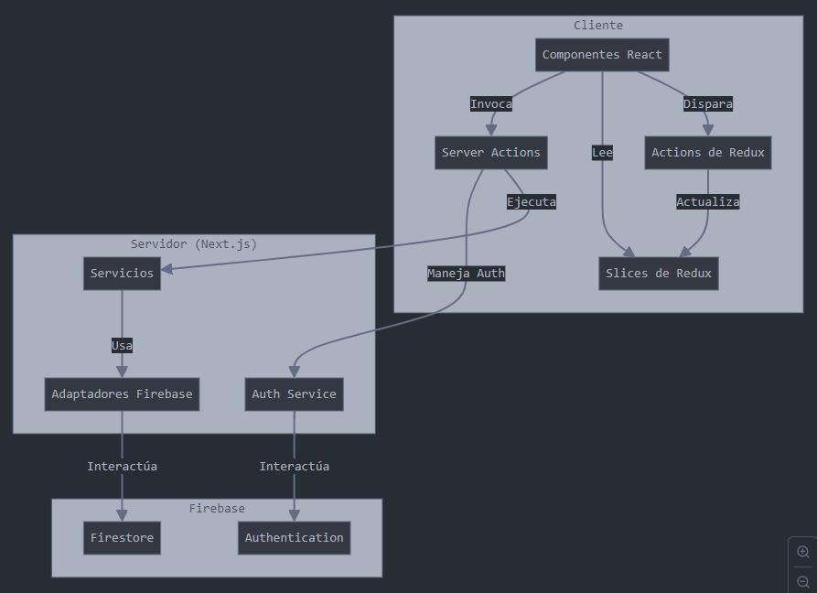

Support Realtime firestore

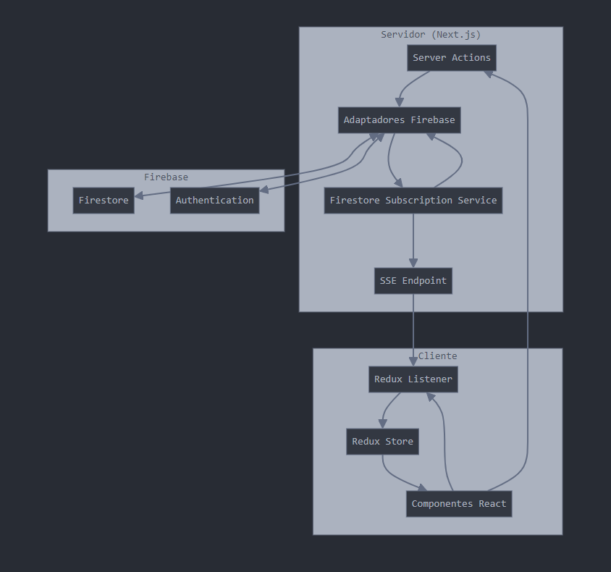

**Preliminary technological guidelines**

- use of typescript

- strongly typed

- avoid the use of "any"

- create interfaces to model the documents stored in firestore

- use generic "T" components and if possible do not use concrete types except in the highest layers (components)